PHW1

201636417 심우석

Source code:

*# Import Class Libraries*import pandas as pd  
import numpy as np  
from scipy.stats import stats  
from sklearn.model_selection import GridSearchCV, train_test_split  
from sklearn.preprocessing import OrdinalEncoder, OneHotEncoder, LabelEncoder  
from sklearn.preprocessing import StandardScaler, RobustScaler, MinMaxScaler, MaxAbsScaler  
from sklearn.tree import DecisionTreeClassifier  
from sklearn.linear_model import LogisticRegression  
from sklearn.svm import SVC  
from imblearn.over_sampling import SMOTE  
from sklearn.feature_selection import SelectKBest, f_classif, f_regression  
  
*##############################################################################################  
# FindBestAccruacy (X, y, scale_col, encode_col, scalers = None, encoders = None,  
# models = None, model_param = None, cv = None, n_jobs = None)  
# Description = When parameters are put in, the highest accuracy and the best model are output  
# Input = X: Data Feature  
# Y: Data Target  
# Scale_col: columns to scaled  
# Encode_col: columns to encode  
# Scalers: list of scalers  
# None: [StandardScaler(), RobustScaler(), MinMaxScaler(), MaxAbsScaler()]  
# If you want to scale other ways, then put the scaler in list.  
#  
# Encoders: list of encoders  
# None: [OrdinalEncoder(), OneHotEncoder(), LabelEncoder()]  
# If you want to encode other ways, then put the encoder in list.  
#  
# Models: list of models  
# None: [DecisionTreeClassifier(criterion=’entropy’), DecisionTreeClassifier(criterion=’gini’),  
# LogisticRegression(), SVC()]  
# If you want to fit other ways, then put the (Classification)model in list.  
#  
# Model_param: list of model’s hyperparameter  
# DecisionTreeClassifier(criterion=’entropy’)’s None: [random_state: None (int), max_depth: None (int),  
# Max_features: None (auto, sqrt, log2), max_leaf_node: None (int)]  
# DecisionTreeClassifier(criterion=’gini’)’s None: [random_state: None (int), max_depth: None (int),  
# Max_features: None (auto, sqrt, log2), max_leaf_node: None (int)]  
# LocisticRegression()’s None: [penalty: None (l2), random_state: None (int),  
# C: None (float), Solver: None (lbfgs, sag or saga), max_iter: None (int)]  
# SVC()’s None: [kernel: None (linear, rbf, sigmoid), random_state: None(int),  
# C: None (float), gamma: None (int)]  
# If you want to set other ways, then put the hyperparameter in list.  
#  
# Cv = K-Fold cross validation’s K  
# None: 5  
# N_jobs = number of jobs to run in parallel. Training the estimator and computing score are  
# parallelized over the cross-validation splits  
# None: 1  
  
# Output = Best Model, Best Accuracy*def FindBestAccruacy(X, y, scale_col, encode_col, scalers=None, encoders=None,  
 models=None, model_param=None, cv=None, n_jobs=None):  
  
 *# Set Encoder* if encoders is None:  
 encode = [OrdinalEncoder(), OneHotEncoder(), LabelEncoder()]  
 else: encode = encoders  
  
 *# Set Scaler* if scalers is None:  
 scale = [StandardScaler(), MinMaxScaler(), MaxAbsScaler(), RobustScaler()]  
 else: scale = scalers  
  
 *# Set Model* if models is None:  
 model = [DecisionTreeClassifier(criterion='entropy'),  
 DecisionTreeClassifier(criterion='gini'),  
 LogisticRegression(), SVC()]  
 else: model = models  
  
 *# Set Hyperparameter* if model_param is None:  
 *# DecisionTreeClassifier('Entropy')* parameter = [{'criterion':['entropy'], 'random_state':[1, 2, 5, 10, 20], 'max_depth':[4, 6, 8, 10],  
 'max_features':["auto", "sqrt", "log2"], 'max_leaf_nodes':[2, 4, 6]},  
 *# DecisionTreeClassifier('Gini')* {'criterion':['gini'], 'random_state':[1, 2, 5, 10, 20], 'max_depth':[4, 6, 8, 10],  
 'max_features':["auto", "sqrt", "log2"], 'max_leaf_nodes':[2, 4, 6]},  
 *# LogisticRegression()* {'random_state':[1, 2, 5, 10, 20], 'penalty':['l2'], 'max_iter':[30000, 50000, 100000],  
 'C':[0.01, 0.1, 1.0, 10.0, 100.0], 'solver':["newton-cg", "lbfgs", "sag", "saga"]},  
 *# SVC()* {'random_state':[1, 2, 5, 10, 20], 'kernel':['linear', 'rbf', 'sigmoid'],  
 'C':[0.01, 0.1, 1.0, 10.0, 100.0], 'gamma':['scale', 'auto']}]  
 else: parameter = model_param  
  
 *# Set CV(cross validation)* if cv is None:  
 setCV = 5  
 else: setCV = cv  
  
 *# Set n_jobs* if n_jobs is None:  
 N_JOBS = -1  
 else: N_JOBS = n_jobs  
  
 best_score = 0  
 best_combination = {}  
 param = {}  
  
 *# SMOTE - Synthetic minority oversampling technique (Fixing the imbalanced data)* target = y  
 smote = SMOTE(random_state=len(X))  
 X, y = smote.fit_resample(X, y)  
  
 *####################################################################  
 # Iterate* for i in scale:  
 for j in encode:  
  
 *# Scaling* df_scaled = pd.DataFrame(i.fit_transform(X[scale_col]))  
  
 *# Encoding* if encode_col is not None:  
 if j == OrdinalEncoder():  
 df_encoded = j.fit_transform(X[encode_col])  
 df_prepro = pd.concat([df_scaled, df_encoded], axis=1)  
  
 else:  
 dum = pd.DataFrame(pd.get_dummies(X[encode_col]))  
 df_prepro = pd.concat([df_scaled, dum], axis=1)  
  
 else:  
 df_prepro = df_scaled  
  
 *# Feature Selection Using the Select KBest (K = 6)* selectK = SelectKBest(score_func=f_regression, k=6).fit(df_prepro, y.values.ravel())  
 cols = selectK.get_support(indices=True)  
 df_selected = df_prepro.iloc[:, cols]  
  
 for z in model:  
  
 *# Split train, testset* X_train, X_test, y_train, y_test = train_test_split(df_selected, y)  
  
 *# Set hyperparameter* if model_param is None:  
 if model[0] is z:  
 param = parameter[0]  
 elif model[1] is z:  
 param = parameter[1]  
 elif model[2] is z:  
 param = parameter[2]  
 elif model[3] is z:  
 param = parameter[3]  
  
 else: param = parameter  
  
 *# Modeling(Using the GridSearchCV)* grid_search = GridSearchCV(estimator=z, param_grid=param, n_jobs=N_JOBS, cv=setCV)  
 grid_search.fit(X_train, y_train.values.ravel())  
 score = grid_search.score(X_test, y_test)  
  
 *# Find Best Score* if best_score == 0 or best_score < score:  
 best_score = score  
 best_combination['scaler'] = i  
 best_combination['encoder'] = j  
 best_combination['model'] = z  
 best_combination['parameter'] = grid_search.best_params_  
  
 *# Print them* print("Best Score = {:0.6f}".format(best_score), "")  
 print("Best Combination, Model {}, Encoder {}, Scaler {}".  
 format(best_combination['model'], best_combination['encoder'], best_combination['scaler']))  
 print("Hyperparameter {}".format(best_combination['parameter']))  
 return  
  
*#########################################################################################  
# Read the dataset  
# Dataset = The Wisconsin Cancer Dataset  
# Feature = Sample code number, Clump Thickness, Uniformity of Cell Size,  
# Uniformity of Cell Shape, Marginal Adhension, Single Epithelial Cell Size,  
# Bare Nuclei, Bland Chromatin, Normal Nucleoli, Mitoses  
# Target = Class  
  
# Number of Dataset = 699  
# Numerical value = Sample code number, Clump Thickness, Uniformity of Cell Size,  
# Uniformity of Cell Shape, Marginal Adhension, Single Epithelial Cell Size,  
# Bare Nuclei, Bland Chromatin, Normal Nucleoli, Mitoses  
# Categorical value = Class*feature_label = ['Sample_code_number', 'Clump_thickness', 'Uniformity_of_cell_size',  
 'Uniformity_of_cell_shape', 'Marginal_adhension', 'Single_epithelial_cell_size',  
 'Bare_nuclei', 'Bland_chromatin', 'Normal_nucleoli', 'Mitoses']  
target_label = ['Class']  
  
df = pd.read_csv("breast-cancer-wisconsin.data", header=None,  
 names=feature_label+target_label)  
  
*# Print Cancer data's information  
# print("\n*************** Cancer ****************")  
# print(df.head())  
  
# print("\n************** Description ***************")  
# print(df.describe())  
  
# Check null value  
# print("\n************** Check null ***************")  
# print(df.isna().sum())  
  
# Drop Sample code number(ID)*df = df.drop(["Sample_code_number"], axis=1)  
feature_label.remove("Sample_code_number")  
  
*# Cleaning Dirty data*df = df.replace('?', np.NaN)  
df = df.fillna(method='ffill')  
  
*# Casting type Bare_nuclei column*df['Bare_nuclei'] = pd.to_numeric(df['Bare_nuclei'])  
  
*# Cleaning Dirty Data, Remove outliers using Z score (>, < 3)  
# Remove Outliers with z-score  
# Description = Use the z-score to handle outlier over mean +- 3SD  
# Input = dataframe's column  
# Output = index*def find_outliers(col):  
 z = np.abs(stats.zscore(col))  
 idx_outliers = np.where(z > 3, True, False)  
 return pd.Series(idx_outliers, index=col.index)  
  
for n in range(10):  
 idx = None  
 idx = find_outliers(df.iloc[:, n])  
 df = df.loc[idx == False]  
  
  
*# print("\n******** Removed Outlier ******")  
# print(df.describe())  
  
# Set X, y data*y_data = df.loc[:, target_label]  
X_data = df.drop(target_label, axis=1)  
  
*# Auto Find Best Accuracy*print("Auto Find Best Accuracy")  
FindBestAccruacy(X_data, y_data, scale_col=feature_label, encode_col=None)  
  
*# Setting some values*print("\n\n\nSetting some values")  
FindBestAccruacy(X_data, y_data, scale_col=feature_label, encode_col=None,  
 scalers=[StandardScaler(), MinMaxScaler()], encoders=[OneHotEncoder(), LabelEncoder()],  
 models=[DecisionTreeClassifier(criterion='entropy'), DecisionTreeClassifier(criterion='gini')],  
 model_param={'random_state':[1, 5, 10], 'max_depth':[4, 6, 8],  
 'max_features':["auto", "sqrt", "log2"], 'max_leaf_nodes':[2, 4, 6]})

Result:

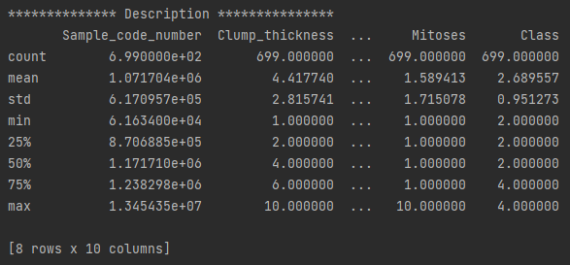

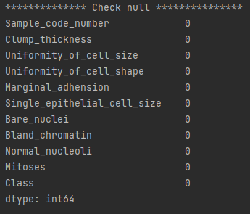

As a result of automatically finding the optimal combination after entering only the label values of the features to be scaled and encoded, X and y.

Try 1

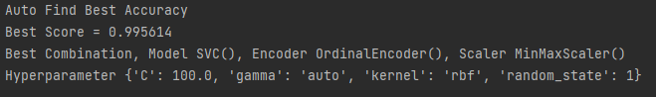

Try 2

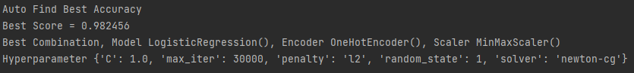

Try 3

Try 4

Try 5

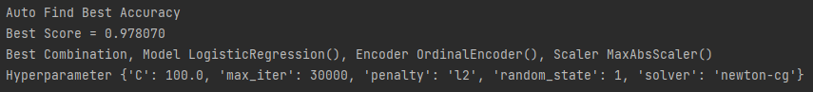

The combination that was chosen that most is Model – SVC(), Encoder – OnehotEncoder(), Scaler – Robust, MinMaxScaler().

The most accurate one is 99.561% !!!

data preprocessing was detailed, so good results were obtained generally.

The value that received the result after setting the specific values.

